ARLEY PARISH COUNCIL
ACM

Notice is hereby given that the ACM of Fillongley Parish Council
will be held on Thursday 7th May 2026 at 7.40 pm

AGENDA
- Election of Chairman

- Election of Vice Chairman

- Signing of Declarations of Acceptance & Declarations of Interest

- Apologies for absence

- Minutes of the Previous Meeting

- Review of All Policies and decisions of new policy requirements

7. Any Other business

Signed 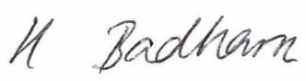

Mrs Heather Badham
Locum Clerk to the Council

